TEXT EDITOR IN JAVA

-S.NIVEDHA SRI
Msc Software Systems

INTRODUCTION

The project is based on “Text Editor”. This project is carried out at Netmax Technologies. This software firm deals in developing software for its clients.

Text Editor: - A text editor is a type of program used for editing plain text files. A plain text file is represented and edited by showing all the characters as they are present in the file. The only characters usable for 'mark-up' are the control characters of the used character set; in practice this is newline, tab and form feed. The most commonly used character set is ASCII, especially recently, as plain text files are more often being used for programming and configuration, and less frequently for documentation (e.g. detailed instructions, user guides) than in the past.

Features
Our text editor provides basic features of an editor.

- String searching - search string with by typing it in search string.
- Cut, copy, and paste - most text editors provide methods to duplicate and move text within the file, or between files.
- Multiple font colors – The editor provides 4 different font colors to make a text more interactive and attractive.
- Fonts – the editor provides all fonts that can be used to make a text more appealing.
- Dock- the editor provides a very interactive graphical user interface in which there is a dock. The dock consist those options which are in frequent use for e.g. cut, copy, paste etc.

Project Overview

PROJECT NAME : Text Editor
PROJECT TYPE : Development Project
FRONT END : Java swings ,AWT.
TOOLS : Notepad Editor, Edit Plus 3

This project “Text Editor” is software which can edit plain text. It is made using Java Swings and AWT.
In this project all the frames are designed in Swing. Today most programmers use Swing. Swing is a set of classes that provides more powerful and flexible GUI components than does the AWT. Swing provides the look and feel of the modern Java GUI.

Swing did not exist in the early days of Java. Rather, it was a response to deficiencies present in Java’s original GUI subsystem: the Abstract Window Toolkit. The AWT defines a basic set of controls, windows, and dialog boxes that support a usable, but limited graphical interface.

Java
Java is a programming language originally developed by James Gosling at Sun Microsystems (which is now a subsidiary of Oracle Corporation) and released in 1995 as a core component of Sun Microsystems' Java platform. The language derives much of its syntax from C and C++ but has a simpler object model and fewer low-level facilities. Java applications are typically compiled to byte code (class file) that can run on any Java Virtual Machine (JVM) regardless of computer architecture. Java is a general-purpose, concurrent, class-based, object-oriented language that is specifically designed to have as few implementation dependencies as possible. It is intended to let application developers "write once, run anywhere". Java is currently one of the most popular programming languages in use, and is widely used from application software to web applications.
The original and reference implementation Java compilers, virtual machines, and class libraries were developed by Sun from 1995.

JFC and Swing is a part of java extension. JFC is short for Java Foundation Classes, which encompass a group of features to help people build graphical user interfaces (GUIs). The JFC was first announced at the 1997 Java One developer conference and is defined as containing the following features:

- The Swing Components

Include everything from buttons to split panes to tables.

- Pluggable Look and Feel Support

It gives any program that uses Swing components a choice of looks and feels. For example, the same program can use either the Java look and feel or the Windows look and feel. We expect many more look-and-feel packages -- including some that use sound instead of a visual "look" -- to become available from various sources.

- Accessibility API

It enables assistive technologies such as screen readers and Braille displays to get information from the user interface.

- Java 2DTM API (Java 2 Platform only)

It enables developers to easily incorporate high-quality 2D graphics, text, and images in applications and in applets.

- Drag and Drop Support (Java 2 Platform only)

Provides the ability to drag and drop between a Java application and a native application.
The Swing API is available in two forms:
- As a core part of the Java 2 Platform, Standard Edition (including versions 1.2, 1.3, and 1.4)
- JFC 1.1 (for use with JDK 1.1)
Sun community recommends that to use the latest version of the Java 2 Platform. Not only will you be getting the latest bug fixes, but you'll get more features. (As we used JSDK1.5.0_01 version, which is the latest release of java development kit up to the time of written of this report.)

SNAPSHOTS

1. Main window
This is the GUI of text editor it includes the dock under the menu bar and text space for editing the text. The look and feel is default look of Operating system.
This window appears when we run the editor.java in command prompt.
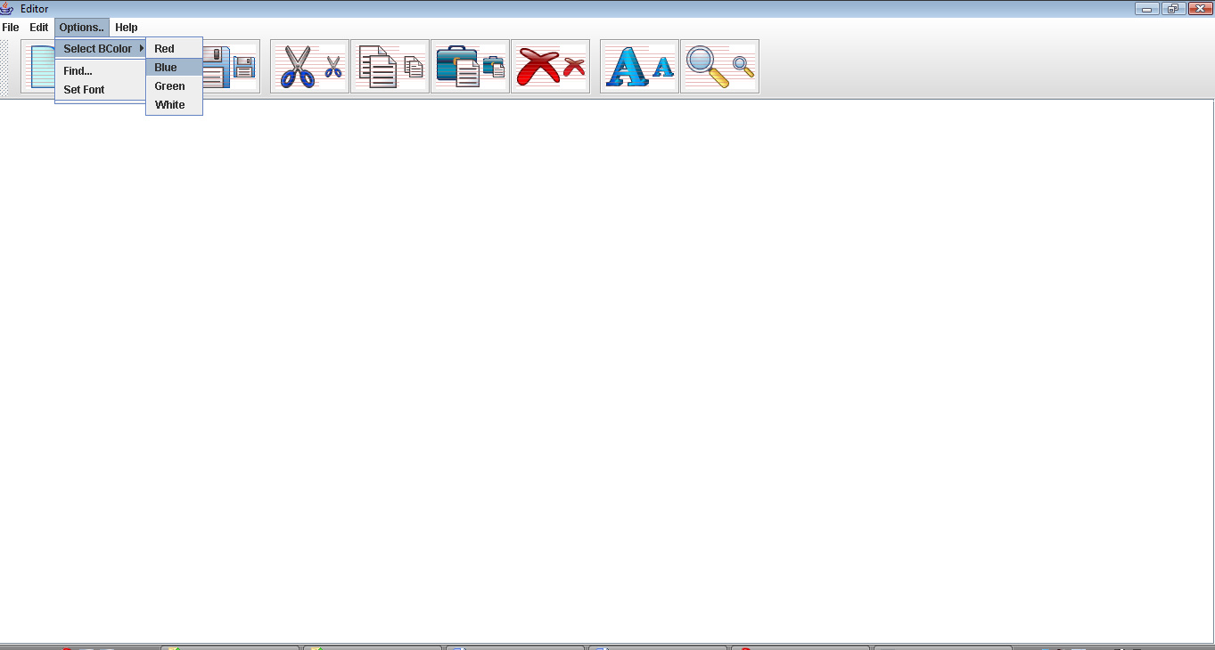

Figure 4: main window

2. Opening a file
This window appears when we click on the open option on the Dock or in the file menu
The file menu is created using JMenu class.

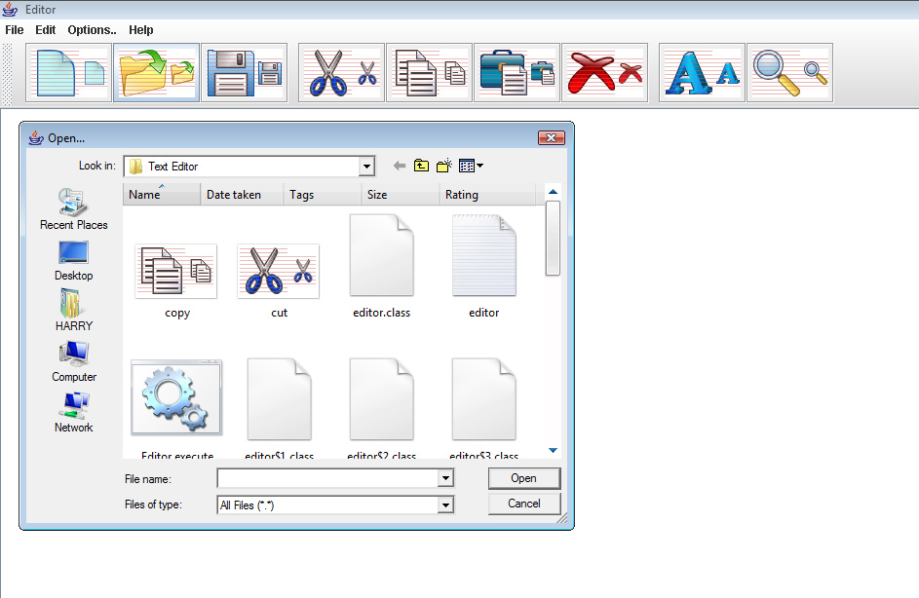

Figure 5: Opening a file

3. Saving a file

This window appears when we want to save the file. The shortcut Ctrl+s do not work here so we can do it using file menu or option on the Dock.

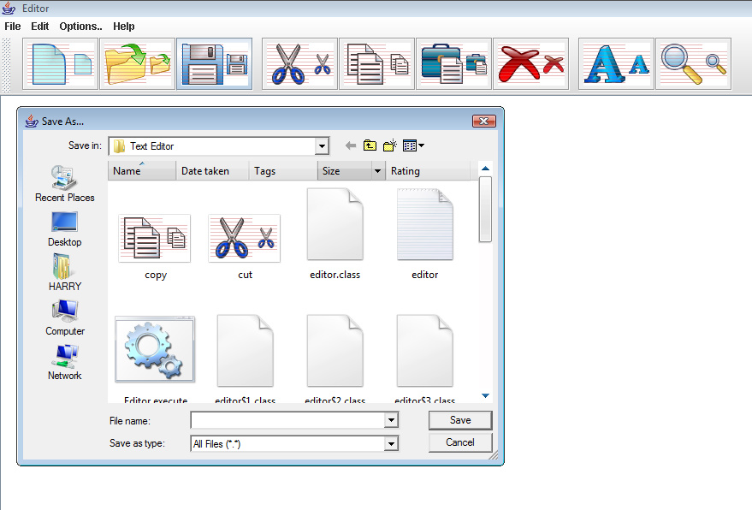
Figure 6: Saving a file

4. Fonts

This menu appears when we want to select the font. This is named as font selector.

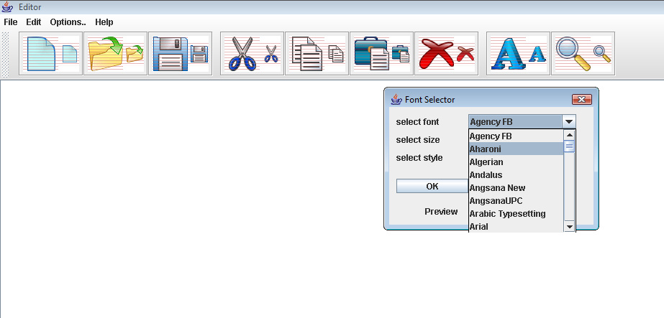

Figure 7: Fonts

Conclusions

This project that I undertook was truly a very rewarding experience for me in more than one way. It has given a big thrust to my technical knowledge as prospective Software professional. It has also helped me enhance my skills on the personal front.

And I feel extremely satisfied by the fact that I have managed to develop the project of course with equal contribution from my team members. I think I have exploited the opportunity that came my way to the fullest extent by increasing my technical know-how and also gaining the valuable work experience apart from studying the other subjects in our curriculum.

Bibliography

The referred books were
1. Java 2-Complete reference (5th edition) by Herbert Schildt
2. Thinking in Java by Bruce Eckel.

And the following websites were also used for reference
1. http://en.wikipedia.org/wiki/Java_(programming_language)/
2. http://download.oracle.com/javase/tutorial/
3. http://www.developer.com/java/
4. http://java.sun.com/docs/books/tutorial
5. http://www.cafeaulait.org/course/
6. http://oopweb.com/Java/Documents/IntroToProgrammingUsingJava/VolumeFrames.html

TABLE OF CONTENTS

Nomenclature Page no.
Certificate i
Acknowledgement ii
List of figures iii
Table of contents iv

1. Preface 1
2. Introduction 2
3. Project Overview 3
4. SDLC 4-
  - System/Information Engineering and Modeling 4
  - Software Requirements Analysis 4
  - Systems Analysis and Design 5
  - Code Generation 5
  - Testing 5
4.6 Maintenance 5

5. Java 6-
5.1 History 6
5.2 characteristics 7
5.3 The Java Platform 8
5.4 What can java do? 9
5.5 JFC and Swings 10
6. Snapshots 12-
6.1 Main window 12
6.2 opening a file 13
6.3 Saving a file 14
6.4 Fonts 15
7. Conclusion 16
8. Bibliography 17

LIST OF FIGURES

Figure Page no.

1. Java programming steps 7
2. Write once run everywhere 8
3. Java API 9
4. Main window 12
5. Opening a file 13
6. Saving a file 14
7. Fonts 15

